Mobile Computing :

Architecture :

IoT Gateway

HTTP Endpoint

Rest Endpoint 1

Rest Endpoint 2

Rest Endpoint 3

Decision Control Unit

State Threshold

State Comparator

Actuation Command

State Retrieval

CoAP Endpoint

Target Uri 1

Target Uri 2

Target Uri 3

Payload Parsing

State Generation

CoAP Semantics and Resource Discovery :

Service Discovery Implemented when the protocol and endpoint URI are both not known.

Example : In HTTP through DNS Query

Environment Requirement : Improving Battery Life involves CoAP endpoints not being queried for a measurement at smaller intervals.

2 Methods to improve the fidelity of resources :

* Caching and Proxying
* Resource Observation

CoAP Resource Observation :

Caching : Storing Resource representation by a CoAP endpoint for the lifetime of the measurement as defined by the sensing endpoint.

Firmware Updates and Log Transfer:

Typical CoAP payload transfer is of order of 10s of bytes. But for firmware update or periodic log recovery into the database or for centralized analytics , block transfer can be used.

CoRE Resource Discovery :

Weblink Format defines resource discovery in Constrained Restful Environments.

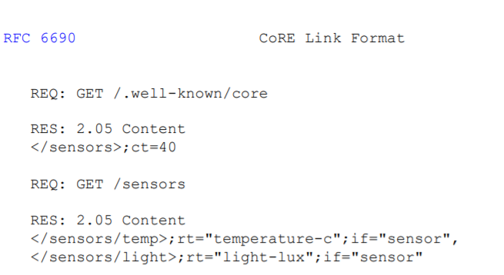

Example with IpSO Semantics :

Interface Semantics :

The more general approach will be to have a centralized well known Resource Directory where CoAP endpoints register itself and the CoAP Gateway queries the well-known resource directory.

Architecture :

